OFFICE OF THE
HUMAN RESOURCES
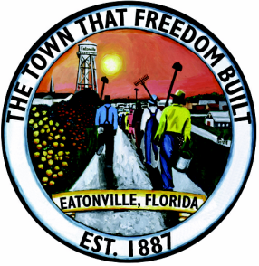

"The Oldest Incorporated Black Municipality in America"

The Town of Eatonville
Position: CRA/PLANNING DIRECTOR

RE: Recruiting in the Central Florida Area

The Town of Eatonville is seeking a highly qualified candidate to fill the position of Community Redevelopment Director/Planning Director. The ideal candidate will be a visionary Planner with demonstrated experience in local Municipal Planning. The role demands a clear vision, open minded, urgency and decisiveness in the development of the Town of Eatonville. The Town of Eatonville is a small Community with approximately 2,500 +/- permanent residents, we are situated between Maitland, and Winter Park, and just 5 miles West of Orlando, Florida, and all the Central Florida Attractions. We offer a competitive Starting Salary; of $71,000 or DOQ. Excellent benefits package. Please submit your Resume’ to the Interim Chief Administrative Officer, Cathlene Williams, PO Box 2163, Eatonville, Florida 32751, or email; cwilliams@townofeatonville.org
Position is open until Filled

